MARINE BIOLOGY ANOVA
Hypothesis:
1.Shrimp are more abundant in the vicinity of cold-water corals than away from corals
INTRODUCTION
Cold-water coral (CWC) reefs are dynamic, extreme environments. Commonly situated at depth far too great for divers to reach, the robotic exploration of these ecosystems has been on the increase during the last 10 years.
As with tropical coral reefs, CWC reefs are known for a high biodiversity and abundance of animal individuals. Sessile (fixed) animals like corals are relatively easy to count, whereas mobile animals can be more difficult, escaping from ROVs etc.
In this study, instrument platforms (Campods) were flown ~1m above the reef environment at ~1m s⁻¹. A camera faced vertically downward with a fixed lamp providing illumination. Two reefs on the Norwegian margin were visited – the Rost reef and the Sotbakken reef.
Shrimp are very abundant in areas of Norwegian waters, and several species are of commercial interest. In the last few years there has been anecdotal evidence published indicating that shrimp may be more abundant at CWC reefs than off reefs. This is of interest to fisheries as a loss of CWC environments may then have an impact on the commercial interests of fishermen. In this brief study we will investigate with a small dataset whether or not shrimp are indeed more abundant in the vicinity of corals than away from corals.
DATA
Two sets of 20 images are provided:
DATA_Rost_shrimp 20 images of the seafloor from the Rost reef
DATA_Sotbakken_shrimp 20 images of the seafloor from the Sotbakken reef
SOFTWARE AND WEB LINKS
(visit the resources page for links : http://imageanalysis.weebly.com/resources.html)
ImageJ will be required on your work computer
Access to ANOVA analysis is required.
TASKS
Several investigations can be made with this data. To investigate the hypothesis ‘Shrimp are more abundant in the vicinity of cold-water corals than away from corals’ the following steps should be followed:
- Images from the two datasets should be combined and then divided into image sets with no or few corals present, and those with lots of corals present.
- Each of the images should be opened in ImageJ and the numbers of shrimp counted. The example below shows how the shrimp can be spotted, by the blurred bright reflections of their eyes.
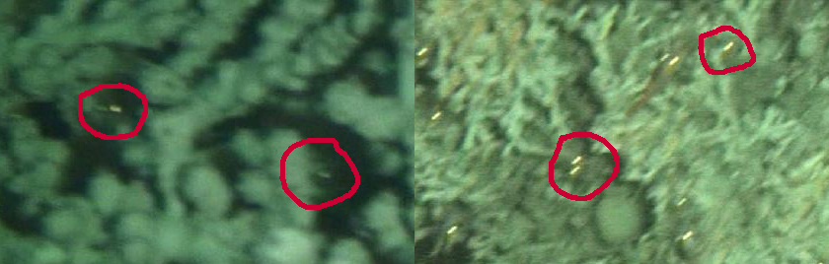
- The shrimp numbers for the two types of images should be compared with an ANOVA test – use SPSS, R, or whichever method you like to carry out the analysis.
- Is there a significant difference between shrimp abundance and coral presence / absence? Further tests can also be run, comparing shrimp densities between the two reefs, for example.
- Feel free to write a short summary of your findings. Please comment on :
the suitability of the methodology in answering the research question – do you see any strengths or drawbacks with the experimental or analytical approaches?, on the statistical results given by the ANOVA and any other observations or opinions.
Email your summary to a.purser@jacobs-university.de for checking and for combining with the other group data.

