JACOBS UNIVERSITY STATS LECTURE - Guide to ImageJ
ImageJ is a freely available piece of software for generating numerical data from images. Though simple to use, it has been cited 1000’s of times in many areas of scientific research in peer reviewed papers.
Please follow the link on the IASS webpage to download the correct version for your own PC:
http://imageanalysis.weebly.com/resources.html

The application was developed for medical applications, to allow various sorts of cells within tissues to be labelled. In recent years the applications have been greatly varied, from counting creatures on the seafloor to craters on the moon, the application can be used for:
- Determining linear distances in images. (Lengths of ice cracks on Europa, lengths of animal tracks, distances between animals)
- Determining areas within images (Areas of a seafloor type, areas made up of lunar highlands or lowlands)
- Quantifying points in an image or image area. (e.g. Craters on the moon, starfish on a seabed, burrows in mud)

These three simple tasks are demonstrated here.

Opening the ImageJ interface:
As soon as you start up ImageJ, you get this menu bar appear:
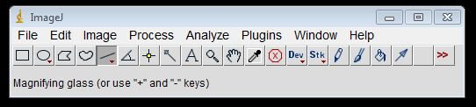
ImageJ window GUI.
Opening an image:
Go to ‘File’, select ‘Open’, navigate to the image you want.
If the image is big, it may well be viewed at less than 100% size. Change this in ‘Image’>’Zoom’
- Determining pixel distances:
The image above shows the 5th tool highlighted. This is the line tool. With it selected, press and hold the left mouse button to draw a line onto the image, releasing the button where you want the line to end, as shown:
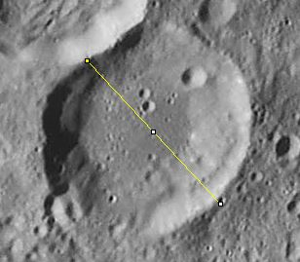
After releasing the button, go to ‘Analyze’, ‘Measure’… this give the following table popup:
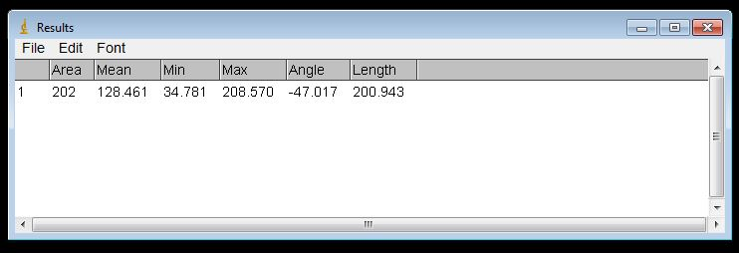
The length of the line, in pixels is given.
If further lengths are required, repeat the measurement procedure. The initial line will vanish from the image, but the new length will appear in the results window below the last measurement:
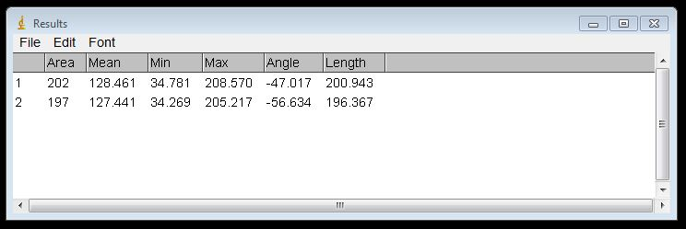
2) Determining pixel areas:
To determine the area of a feature, in pixels, the 3rd or 4th tools can be used, the ‘polygon selector’ and the ‘freehand selector’. Here we use the ‘polygon selector’ to draw the outline of a crater by left clicking a chain of lines around the crater rim. When the last line returns to the initial box (the start of the first line) the polygon is completed, as here:
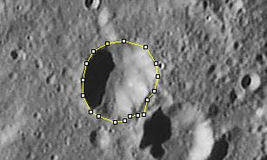
To determine the area, go to ‘Analyze’, ‘Measure’…
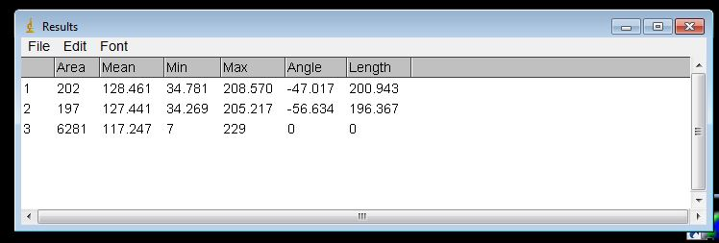
The latest measurement is placed in the Results window below the others.

- Quantifying points within an image
The procedure to count points within an image is a little different. Here in this example we will quantify the numbers of shrimp on various types of seafloor:
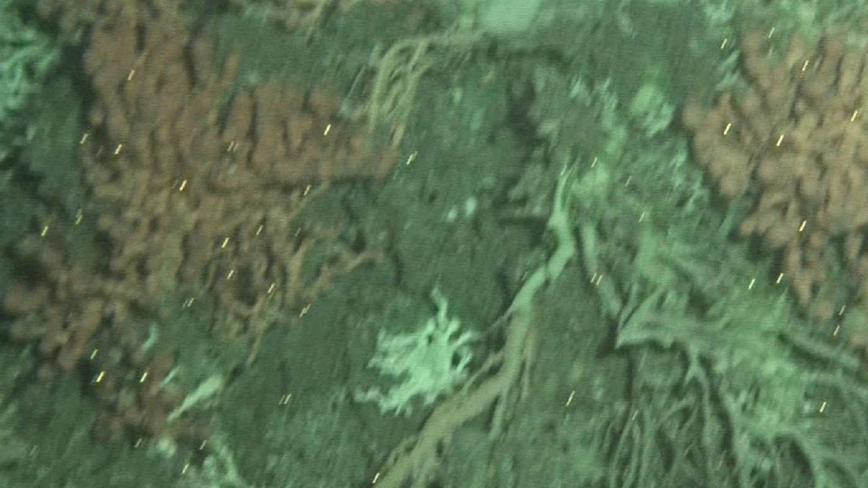
The shrimp are the bright dots. The red material is ‘Bubblegum coral’ and the grey background is ‘Seabed’ – for our purposes.
To open the image in ImageJ, go to ‘File’,’Open’ and navigate to your image.
Next, go to ‘Plugins’, ‘Analyze’, ‘Cell counter’… the following window should pop up:
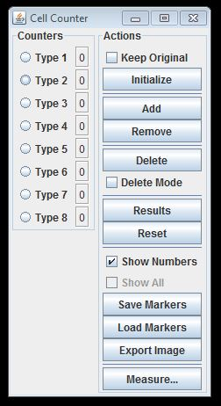
The left hand column, ‘Counters’ shows that 8 sorts of point can be counted. For this example, Type 1 will be shrimp on ‘Bubblegum coral’, Type 2 will be shrimp on ‘Seabed’.
The first thing to do is press ‘Initialize’ in the window. This may cause the image to resize, so you may have to go to ‘Image’,’Zoom’ on the main ImageJ interface to correct this.
Next, select the ‘Type 1’ radio button and mark all the shrimp on ‘Bubblegum coral’.
Next, select the ‘Type 2’ radio button and mark all the shrimp on ‘Seabed’.
After doing this, you should see an output like this:
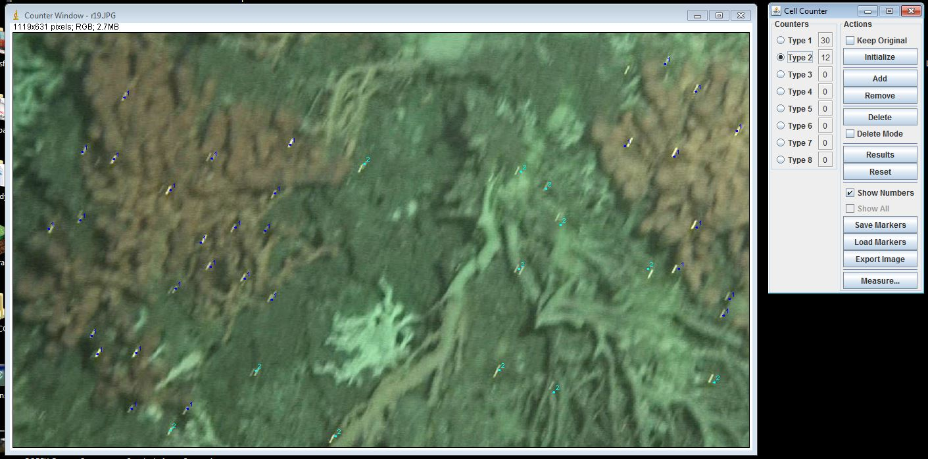
Pressing the ‘Results’ button will export the counts to the ‘Results’ window, thus:
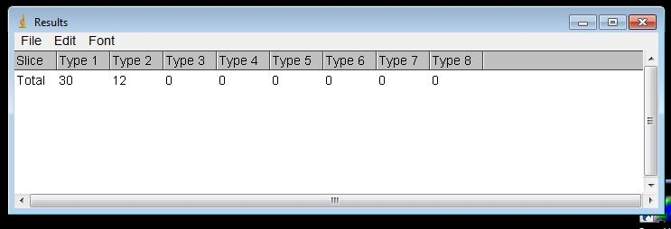

…And that is it for the basic operations of ImageJ.

